**Azure**

**Azure Functions**

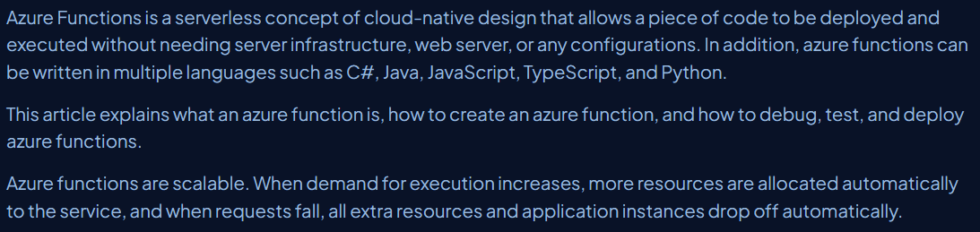

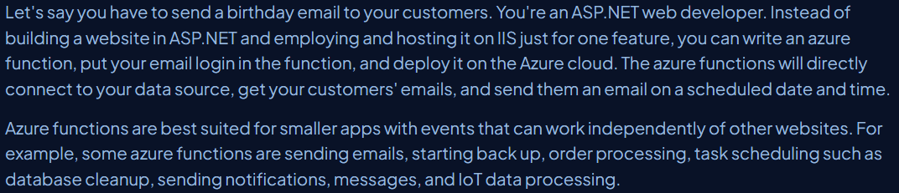

**Create a azure function in C#**

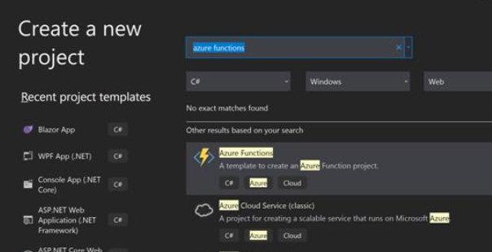

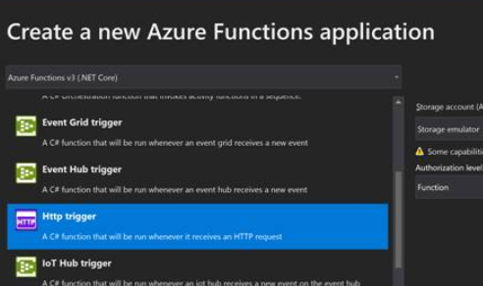

**This url can be accessed by any other projects to achieve the execution.**

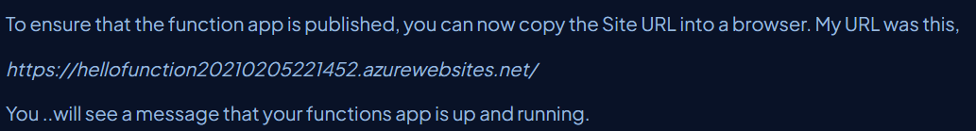

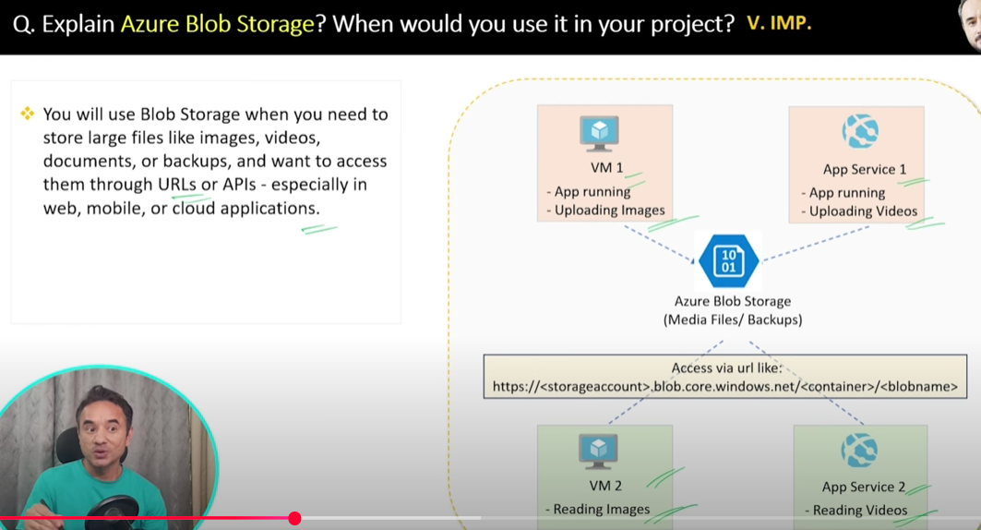

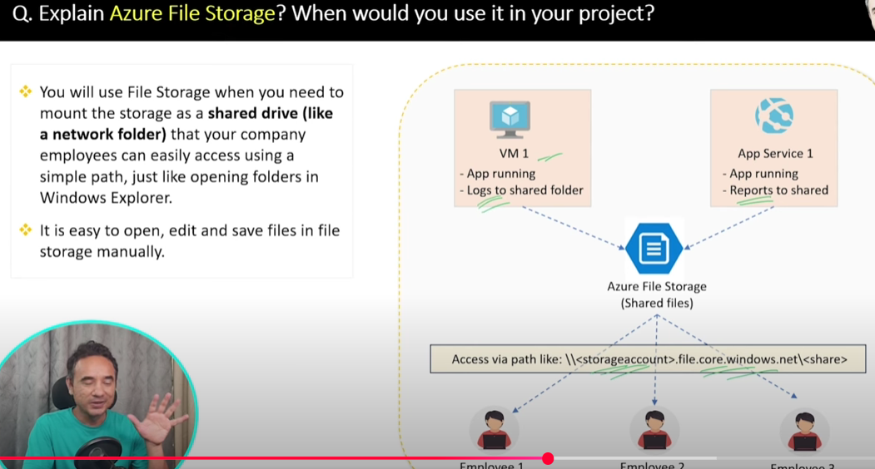

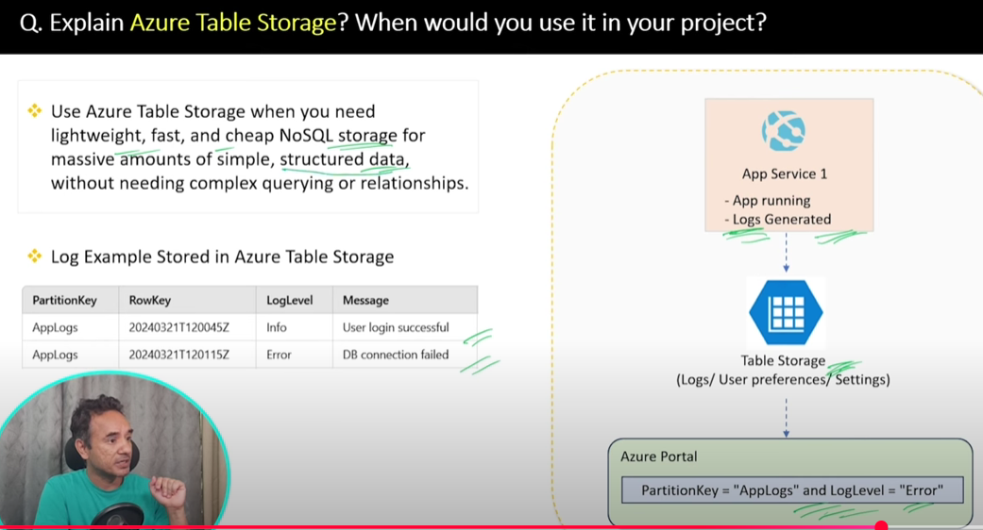

**Azure Service Bus**

